Campaigning and Political Activity Guidance for Charities.

YFC is politically neutral which means is doesn’t show affiliation to a particular political party

Having said that it must be remembered that YFC has an interest in how government policies affect its membership and therefore represents the voices of young people within industry and at relevant government meetings/forums

The Charity Commission has made clear that campaigning is a legitimate activity for a charity/charities, including during elections. The law states that charities must be independent of party politics. That means they can’t give their support to, or fund, political parties or candidates. Therefore, YFCs as charities can take part in political activity (supporting or opposing a policy for example) provided it supports their purpose and is in their best interests.

Note: Political activity is not the reason for YFCs’ existence. Charities must remain independent and must not give their support to a political party – all charities should make sure they’re seen as politically independent by the public.

- Charities can support and oppose the policies of political parties.
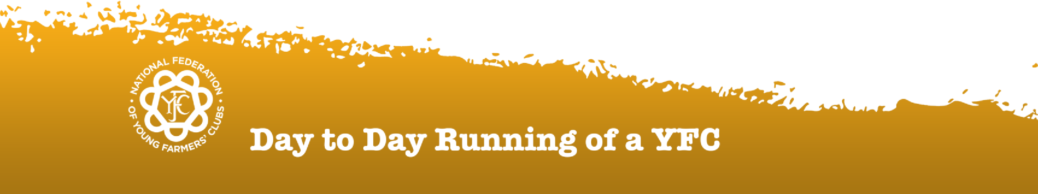

- Charities must consider how this might affect perceptions of the charity’s independence.

YFC Image
–

Campaigning & Media
Exposure

- If a party adopts a policy that aligns with a longstanding policy ask or the charitable purposes, there is unlikely to be any issue if welcoming that support and calling on other parties to adopt it.
- If a party adopts a policy that the charity opposes, it can criticise the policy. The criticism must relate to the charitable purposes and the impact on the people you support.
- Think carefully about the tone of any statements. It’s likely to influence how people perceive the political independence of the charity. Make sure any disagreement or criticism of a policy is constructive and based on evidence.
- This also applies to highlighting when a party or candidate endorses your asks. It’s fine to point this out. However, if you put too much focus on it, it may come across as biased toward their political party.
- If criticism the charity (YFC) makes thought statements is consistent with all previous public statements, people will be less likely to question the charity’s political independence.

Therefore, the answer to ‘Can we display a poster/banner of a political nature’? is:
- The county federation can oppose/support a policy and display a banner or join an event supporting British farming. Opposing/supporting a policy is acceptable as this is independent and different from supporting or opposing a political party.
- Do not use text or images that criticise individuals, such as Ministers of MP’s or celebrities – this will be viewed as offensive to those that do not share the same position as you.
- The best advice is to share positive and informative messages regarding food and farming i.e. Back British Farming

As we consider the changes to policies regarding Agricultural relief on Inheritance Tax, the YFC and NFYFC may wish to:
- Oppose or disagree as this has an impact on young and old (all those farming), many of which are current YFC members and there is no doubt that our members will be impacted. ➢ Ensure that our statements are constructive and factual (evidence based).

The NFYFC AGRI department’s advice is also as follows:
- NFYFC is currently a Defra ‘stakeholder’ and therefore invited to various Defra or industry meetings to represent the voice of next generation young farmers/rural young people
(If we interact with other government departments, the same action would be taken.)
- The AGRI Ambition document is the YFC AGRI group’s ‘manifesto’ – a document that highlights what topics are of interest and considered of importance by its YFC members. This should be of interest to all.
- We encourage all YFCs to interact with the various levels of councillors (Parish, County/District), MPs and other organisations to ensure that they represent themselves.

Regarding the use of YFC T-shirts to support such campaigns, please only share constructive support for both the food and farming industries and YFCs.

Version

Date

Author

Comments & status

1.0

18.2.2025

NFYFC

New document

YFC Image
–

Campaigning & Media
Exposure

YFC members/supporters featuring on TV Shows and other forms of media
It is important that the reputation of YFC members and YFCs/County Federations and the NFYFC are protected. This is a requirement of the Charity Commission and those responsible for this are all charity trustees (which includes YFC club trustees, County Federation trustees and the NFYFC trustees) and the NFYFC staff (the youth/young people’s workforce).
Past and present experience is that the media puts YFC members and the YFC clubs, County Federations and the NFYFC at risk of reputational harm because YFC clubs, County Federations and the NFYFC cannot protect participants from situations that can be sensationalised by the media – and not in a good way.
Farming organisations including the NFU, CLA and very many others work tirelessly to protect the image of farming and farmers, and any negative media will bring significant harm to the very important campaign and influencing work being done on behalf of the industry by these organisations. The actions of YFC members cannot be distanced from farmers, farming and farming organisations.
As mentioned above, the risks of a TV company inciting inappropriate conduct or editing film to be sensationalised are high, so it is recommended that this is avoided.

